**1. [Ryzen & GTX 1050 Ti Edition] SkyTech Archangel Gaming Computer Desktop PC Ryzen 1200 3.1GHz Quad-Core, GTX 1050 Ti 4GB, 8GB DDR4 2400, 1TB HDD, 24X DVD, Wi-Fi USB, Windows 10 Home 64-bit**

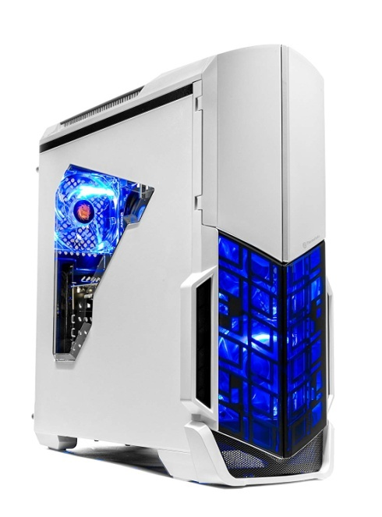

Precio: 633.48$

Descripcion:

✔ AMD RYZEN 3 1200 4-Core 3.1 GHz (3.4 GHz Turbo) | 1 TB 7200RPM Hard Drive | A320M Motherboard

✔ Nvidia GeForce GTX 1050 Ti 4GB Video Card | 8GB DDR4 2400 Gaming Memory | Windows 10 Home 64-bit

✔ Wi-Fi Ready | No bloatware | 1 x Dual-link DVI, 1 x DisplayPort (version 1.4), 1 x HDMI | 9 x USB (4 X USB 2.0; 5 X USB3.0)

✔ Power by 80 Plus Certified 500 Watt Power Supply | Free Gaming Keyboard & Mouse | Monitor Not included

✔ 1 Year Warranty on Parts and Labor | Lifetime Free US Technical Support | Assemble in the USA

**2. iBUYPOWER Pro Gaming PC Computer Desktop Intel i7-9700k 8-Core 3.6 GHz, Geforce RTX 2070 8GB, 16GB DDR4, 1TB HDD, 240GB SSD, Z370, Liquid Cooling, WiFi Ready, Windows 10, VR Ready (Trace 9230, Black)**

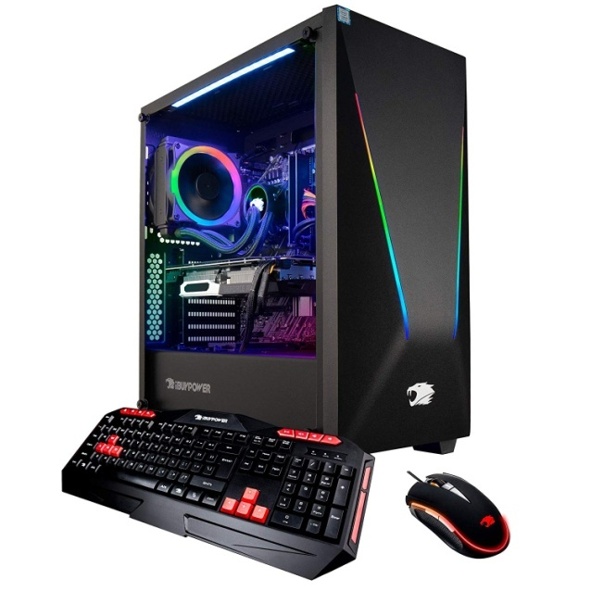

Precio: 1,499.99$

Descripcion:

* System: Intel Core i7-9700k 8-Core Processor 3. 6 GHz (4. 9 GHz Max Turbo) | Intel Z370 Express Chipset | 16GB DDR4 2666MHz RAM | 1TB 7200Rpm HDD | 240GB SSD | Genuine Windows 10 Home 64-bit high-end
* Graphics: NVIDIA GeForce RTX 2070 8GB Dedicated Gaming Video Card | VR Ready | Display Connectors: HDMI, DisplayPort, DVI | play your favorite games on ultra!
* Connectivity: 5 x USB 3. 1 | 1x RJ-45 Network Ethernet 10/100/1000 | Audio: 7. 1 Ch. HD Audio | 802. 11AC Wi-Fi + Bluetooth Ready
* Special Add-Ons: iBuyPower signature trace Tempered glass RGB Gaming Case | Liquid Cooled | 802. 11AC Wi-Fi + Bluetooth Ready | Free iBuyPower Gaming Keyboard & Mouse
* Warranty: 1 Year Parts & Labor + Free Lifetime Tech Support | Assembled in the U. S. A

**3. CyberpowerPC Gamer Master GMA888A Gaming PC (AMD Ryzen 3 2300X 3.5GHz, 8GB DDR4, AMD Radeon R7 240 2GB, 120GB SSD, 1TB HDD, 802.11AC WIFI & Win 10 Home) Black**

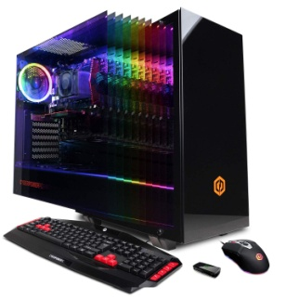

Precio: 599.99$

Descripcion:

* System: AMD Ryzen 3 2300x 3.5GHz 4-Core | AMD A320 Chipset | 8GB DDR4 | 120GB SSD | 1TB HDD | Genuine Windows 10 Home 64-bit
* Graphics: AMD Radeon R7 240 2GB Video Card | 1x DVI | 1x HDMI
* Connectivity: 6 x USB 3.1 | 2 x USB 2.0 | 1x RJ-45 Network Ethernet 10/100/1000 | 802.11AC Wi-Fi | Audio: 7.1 Channel | Gaming Keyboard and Mouse
* Special Feature: Tempered Glass Side Case Panel | Custom RGB Case Lighting | RGB 7 Colors Gaming mouse
* Warranty: 1 Year Parts & Labor Warranty | Free Lifetime Tech Support

**4. CYBERPOWERPC Gamer Supreme Liquid Cool Gaming PC Desktop, Intel Core i7-9700K 3.6GHz, NVIDIA RTX 2070 Super 8GB Graphics, 16GB DDR4, 1TB PCI-E NVMe SSD, WiFi Ready & Win 10 Home (SLC8260A2, Black)**

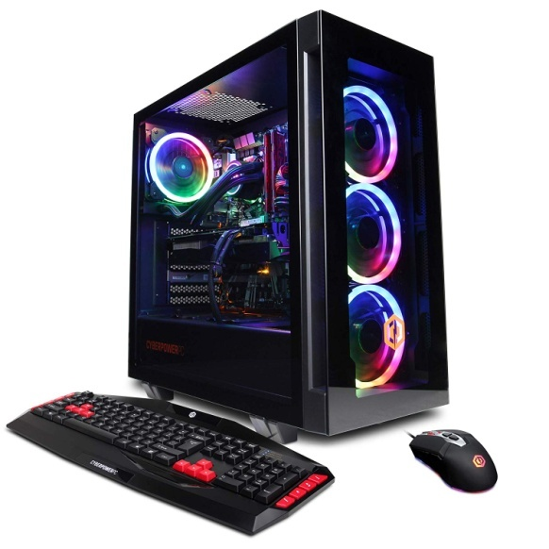

Precio: 1,379.99$

Descripcion:

System: Intel Core i7-9700k 3. 6GHz 8-Core | Intel Z390 Chipset | 16GB DDR4 | 1TB PCI-E NV Me SSD | Genuine Windows 10 Home 64-bit

Graphics: NVIDIA GeForce RTX 2070 Super 8GB Video Card | 1x HDMI | 2x DisplayPort

Connectivity: 6 x USB 3. 1 | 2 x USB 2. 0 | 1x RJ-45 Network Ethernet 10/100/1000 | 802. 11AC Wi-Fi | Audio: 7. 1 Channel | Keyboard and Mouse

Special Feature: Liquid Cooling | Tempered Glass Side Case Panel | Custom ARGB case Lighting | RGB 7 Colors Gaming mouse

: 1 Year Parts & Labor | Free Lifetime Tech Support